**Project Design Phase**

**Problem – Solution Fit Template**

|  |  |
| --- | --- |
| Date | 27 June 2025 |
| Team ID | LTVIP2025TMID21127 |
| Project Name | Sustainable Smart City Assistant |
| Maximum Marks | 2 Marks |

**Problem – Solution Fit Template:**

The Problem–Solution Fit in the context of the Smart City Sustainability Assistant means identifying real, recurring problems faced by citizens, urban planners, and policy implementers in accessing and acting on sustainability data and resources—and ensuring that the AI-powered assistant you're developing directly addresses those challenges in a meaningful, accessible way.

**Purpose:**

* Solve complex urban and sustainability-related problems by making policy insights, city metrics, and citizen engagement tools easily accessible, even for non-expert users.
* Accelerate adoption of eco-conscious behavior and civic engagement by integrating your assistant into common digital channels and daily user behavior (e.g., mobile browsing, voice interaction).
* Sharpen communication through relevant eco-tips, personalized insights, and multilingual support to suit users from diverse backgrounds.
* Increase citizen and stakeholder trust by providing reliable summaries, responsive interfaces, and actionable insights that solve frequent pain points like complex documents, inaccessible data, or language barriers.
* Understand the real-life context—such as regulatory confusion, environmental concern, or data overload—and improve sustainability decision-making for your target users: citizens, city officials, and planners.

**Template:**

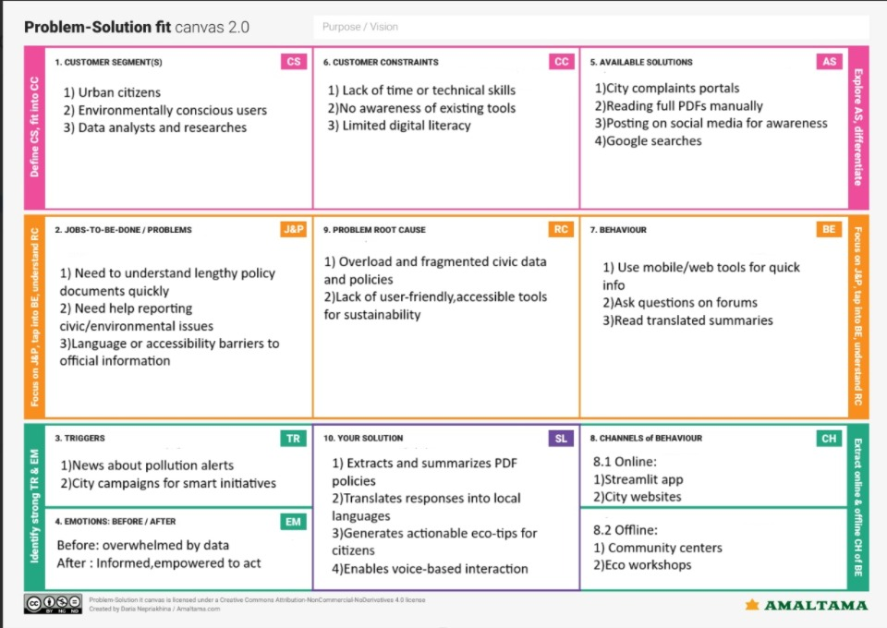

References:

1. <https://www.ideahackers.network/problem-solution-fit-canvas/>
2. <https://medium.com/@epicantus/problem-solution-fit-canvas-aa3dd59cb4fe>